COEXIST

Interaction in coastal waters: A roadmap to sustainable integration of aquaculture and fisheries

Project number: 245178
Start date of the project (duration): April 1st, 2010 (36 months)

Deliverable D3.4

Validated farm-scale models for aquaculture

Organisation name of lead contractor: IMAR

Authors: João Gomes Ferreira, Camille Saurel, Filipa Vazquez

Due date of deliverable: Mxx

Actual submission date: Mxx

Project co-funded by the European Commission within the Seventh Framework Programme (2007-2013)
Dissemination level
PU Public | X
PP Restricted to other programme participants (including the Commission Services)
RE Restricted to a group specified by the consortium (including the Commission Services)
CO Confidential, only members of the consortium (including the Commission Services)

All rights reserved

This document may not be copied, reproduced or modified in whole or in part for any purpose without the written permission from the COEXIST Consortium. In addition to such written permission to copy, reproduce or modify this document in whole or part, an acknowledgement of the authors of the document and all applicable portions of the copyright must be clearly referenced.

List of reviewers

Issue | Date | Implemented by
v.xFINAL

TABLE OF CONTENTS

TABLE OF CONTENTS 3
1. Introduction 4
1.1. General background 4
1.2. Aims and objectives 5
1.3. Model application 5
2. Material and methods 6
2.1. FARM data requirements 6
2.2. FARM outputs 7
2.1. FARM mass balance 7
3. FARM application during the COEXIST project 9
4. Summary fact sheet 9
5. Responsibilities 10
6. References 10

Introduction
  - General background
The Farm Aquaculture Resource Management (FARM) model has been specifically developed for aquaculture. It has been used in many parts of the world, including Europe, the U.S.A., Asia and South America, to model growth and environmental effects of cultivation for different species, both in open water and onshore. In the COEXIST project, the model has been further adapted and validated.

The Farm Aquaculture Resource Management (FARM) model was initially developed to assess coastal and offshore aquaculture of shellfish at the farm scale (Ferreira et al. 2007; Ferreira et al. 2009). The COEXIST version of the model is designed for offshore aquaculture management for both farmer and regulator, and has four main uses:
- biomass estimation and feeding requirements;
- ecological and economic optimisation of culture period (such as timing and sizes for seeding and harvesting, densities and spatial distributions);
- operational optimisation of farming methods;
- profitability assessment.
The model comprises three types of inputs: farm dimension and culture practice, environmental drivers and cultivated species stocks (Figure 1).

Figure 1 FARM-Scale conceptual diagram
  - Aims and objectives
FARM was upgraded for the COEXIST project to simulate the production and impact of new species identified for the different case studies including fish and shellfish and to work on both Windows 32 and 64-bit operating systems:
- Gilthead seabream (Sparus aurata)
- Good Clam (Ruditapes decussatus)
- Manila clam (Tapes philippinarum)
- Mediterranean mussel (Mytilus galloprovincialis)
To use the FARM model, you need to download and install the FARM COEXIST software, which is available on this website: http:/ecowin.org/coexist/farm
Once downloaded from the website and installed on your computer, the model is setup with some default values so that the model can be run immediately and gives default values as an example.
  - Model application
Table 1 summarize all the different application from the different outputs of the model FARM.

Table 1. FARM model applications for the different outputs
Output | Application
Production analysis | Simulation of potential harvest.
Production analysis | Optimisation of harvest timing.
Production analysis | Changes in stocking density, mortality.
Production analysis | Optimum profit structure with respect to stocking density, mortality and food supply.
Production analysis | Calculation of optimum profit output (Average and Marginal Physical Product).
Environmental effects | Deposition analysis.
Environmental effects | Dissolved oxygen and sediment oxygen demand analysis.
Environmental effects | Effect of the farm on water quality.
Environmental effects | Assessment of nutrient input/removal (finfish/shellfish) in the water body.
Environmental effects | IMTA Simulation on water/sediment quality, e.g. combining finfish with shellfish.
Mass balance analysis | Mass balance analysis for offshore farms.
Mass balance analysis | Environmental footprint of offshore farms.
Mass balance analysis | Production analysis, algal growth calculation using dissolved nutrient analysis, other water quality aspects.
Mass balance analysis | Nutrient output for finfish farms.
Mass balance analysis | Nutrient reduction for shellfish.
Farm footprint | Determination of nitrogen and carbon footprint.
Farm footprint | Farm value for nutrient credit trading.
Shellfish | Mediterranean Mussel - Mytilus galloprovincialis  Good clam - Ruditapes decussatus  Manila clam - Tapes philippinarum
Finfish | Gilthead bream - Sparus aurata.

Material and methods
  - FARM data requirements
FARM requires the data supplied in the table 1 below to apply the model. This model is maximised with seasonal/quarterly (minimum) or monthly (ideal) over a year. It probably requires a data monitoring programme to collect the necessary data. Some data points (e.g. temperature) can be acquired or sourced locally from other farms and scientific institutions, whereas other drivers will likely need to be measured.

There are 6 types of data required to fill in and run the FARM model (Table 2 and Figure 2):
- Driver table
- Farm layout
- Environment
- Shellfish/finfish economics and finance
- Shellfish/finfish cultivation
- biodeposition

Table 2. Type of data required to run the FARM model.

Category | Data Type | Units
Farm layout | Coordinates | Lat/Long
Farm layout | Farm width, length and depth; | Metres
Farm layout | Number of sections. | Number
Economic data | Cost of seed | $/1000
Economic data | Sale price | $/kg
Environmental data | Peak current speed at Spring tide; | m/s
Environmental data | Peak current speed at Neap tide; | m/s
Cultivation practice | Species cultivated; | Species
Cultivation practice | Harvest weight; | Grams
Cultivation practice | Mortality; | % per cycle
Cultivation practice | Culture period; | Days
Cultivation practice | Sale price; | $/kg
Cultivation practice | Seeding parameters; | Animals per m²
Cultivation practice | Seed weight and cost per kg. | Grams and $/kg
Drivers | Water temperature; | Degrees Centigrade
Drivers | Salinity; | PSU
Drivers | Chlorophyll a; | μg/L
Drivers | Particulate Organic Matter (POM); | mg/L
Drivers | Total Particulate Matter (TPM); | mg/L
Drivers | Dissolved Oxygen. | mg/L

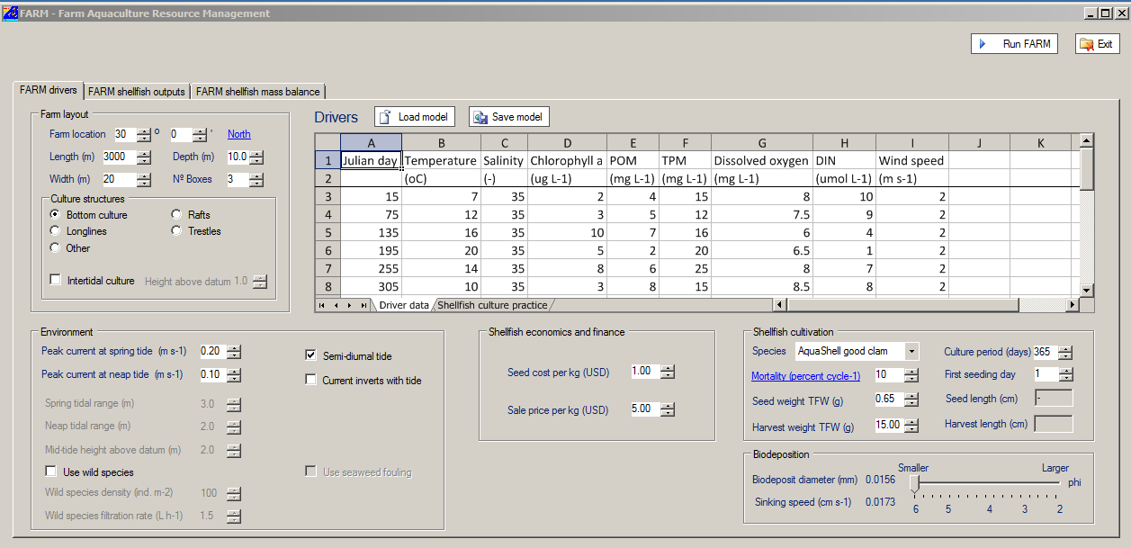

Figure 2. Screen capture of the FARM application once installed with default values

Once the “FARM drivers” data are filled in, press “run FARM” model to get the FARM shellfish/finfish outputs.
The “drivers” can be saved and a previous model can be loaded.
  - FARM outputs
FARM Outputs produces operational insights about animal growth, water quality and profitability with: (i) Harvestable biomass, (ii) Water quality effects, (iii) profitability analysis, (iv) Biodeposition.
FARM biomass, water quality and profitability are calculated and displayed as daily values in the “FARM shellfish/finfish outputs”. A graph of the total harvest and condition index is displayed over the cultivation period chosen (Figure 3). The summary of the production per section of cultivation together with the ASSETS and biodeposition results are presented as spreadsheet in the “Summary” section (Figure 3).

  - FARM mass balance
The FARM mass balance results for nutrient removal and overall water quality effects for shellfish or finfish are presented in the last windows (Figure 4). FARM Mass Balance produces a complete water quality analysis with: (i) Phytoplankton removal, (ii) Detritus removal, (iii) Nutrient removal, (iv) Potential nutrient trading, (v) income and (vi) ASSETS Score using the ASSETS model (http://www.eutro.org/).

Figure 3. Screen capture of the FARM shellfish outputs results for the default values of good clam.

Figure 4. Screen capture of the FARM shellfish mass balance results for the default values of good clam.

FARM application during the COEXIST project

FARM was applied in the Case Study 3, Algarve Coast with the growth production for good clams (Ferreira et al.2012b in press); seabream and oysters (Ferreira et al. 2012a).

Ferreira et al. 2012a Abstract: “A gilthead bream (Sparus aurata) model has been developed and integrated with existing shellfish models in the Farm Aquaculture Management System (FARM) model, in order to analyse various aspects of onshore and offshore aquaculture. The FARM model was used to compare the quantitative effects of finfish monoculture with Integrated Multi-Trophic Aquaculture (IMTA) in ponds, in terms of production, environmental externalities, and economic performance. Very clear benefits of IMTA could be seen in the comparison. The same approach was then applied to offshore culture, considering a combination of gilthead in cages and Pacific oyster (Crassostrea gigas) suspended from longlines.”

Summary fact sheet

FARM model (Farm Aquaculture Resource Management)
Data requirement | Little data requirement see Table 2  Could be coupled offline within FISHRENT (Deliverable 3.3)
Main state variables | Chlorophyll a (chl a), Total Particulate Matter (TPM), Particulate Organic Matter (POM), dissolved oxygen, harvestable shellfish biomass, individual weight and length.  The model can function with constant values or with time series.
Scale | Farm scale from m to km
Knowledge type | Software/modelling tool
How to use it | No help required
Contact - owner | IMAR
Sector application | Policy Makers, Aquaculture industry, Environmental Agencies  NGOs, Scientific Community
Outputs and applications | Production analysis, environmental effects, mass balance analysis, farm footprint, shellfish and finfish - See Table 1
End users | Policy Makers: It could be used as a statutory decision making tool (precautionary approach) and also for law compliance in regions with restriction to aquaculture sites close to each other  Aquaculture industry: It could be used as a commercial planning tool for shellfish. It could also serve to monitor the impact of the aquaculture on the site from an ecological and social perspective.  Environmental Agencies and NGOs: They can use the environmental data from the model  Scientific Community: It could be a training tool for future generations
Present development state | The FARM model has been tested in Sanggou Bay – China, and Carlingford Lough - northern Ireland (Ferreira et al, 2007a and Ferreira et al, 2007b), Ria Formosa – Portugal (Ferreira et al. 2012a & Ferreira et al. 2012b)
Availability & development | FARM models for various species are used free of charge and run directly on the web at http://farmscale.org  The COEXIST version can be downloaded at: http://ecowin.org/coexist/farm/

Responsibilities

Deliverable 3.4: IMAR is in charge of the development of the FARM model.

References

Ferreira, J.G., A.J.S. Hawkins, S.B. Bricker, 2007a. Management of productivity, environmental effects and profitability of shellfish aquaculture – the Farm Aquaculture Resource Management (FARM) model. Aquaculture 264, 160-174.

Ferreira, J. G., Hawkins, A. J. S., Monteiro, P., Service, M., Moore, H., Edwards, A., Gowen, R., Lourenço, P., Mellor, A., Nunes, J. P., Pascoe, P. L., Ramos, L., Sequeira, A., Simas, T. And Strong, J., 2007b. SMILE – Sustainable Mariculture in northern Irish Lough Ecosystems – Assessment of Carrying Capacity for Environmentally Sustainable Shellfish Culture in Carlingford Lough, Strangford Lough, Belfast Lough, Larne Lough and Lough Foyle. Ed. IMAR – Institute of Marine Research. 100 pp.

Ferreira, J. G. , A. Sequeira, A.J.S. Hawkins, A. Newton, T.D. Nickell, R. Pastres, J. Forte, A. Bodoy, S.B. Bricker, 2009. Analysis of coastal and offshore aquaculture: Application of the FARM model to multiple systems and shellfish species. Aquaculture 289, 32-41, doi:10.1016/j.aquaculture.2008.12.017.

Ferreira, J.G., C. Saurel, J.M. Ferreira, 2012a. Cultivation of gilthead bream in monoculture and integrated multi-trophic aquaculture. Analysis of production and environmental effects by means of the FARM model. Aquaculture, 358–359, p. 23–34.

Ferreira, J.G., C. Saurel, J.P. Nunes, L. Ramos, J.D. Lencart e Silva, F. Vazquez, Ø. Bergh, W. Dewey, A. Pacheco, M. Pinchot, C. Ventura Soares, N. Taylor, W. Taylor, D. Verner-Jeffreys, J. Baas, J.K. Petersen, J. Wright, V. Calixto, M. Rocha 2012b. FORWARD - Framework for Ria Formosa Water Quality, Aquaculture, and Resource Development. Ed. IMAR - Institute of Marine Research. In Press.

